PROJECT-10
Weather Forecast Email Notification Using Open-Meteo API
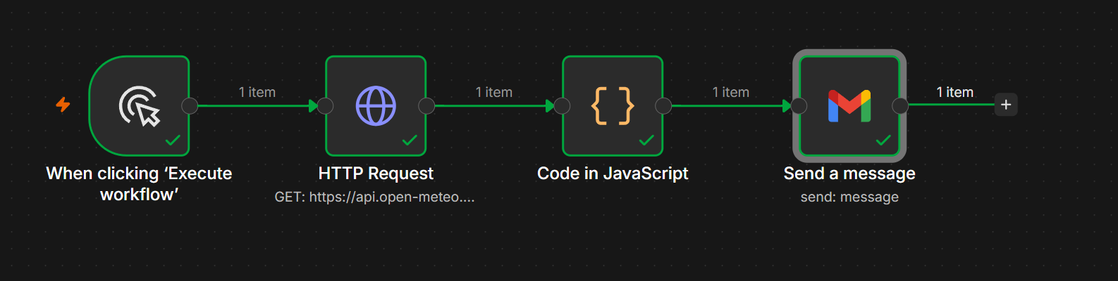

Project Overview
This workflow automatically retrieves weather forecast data from the Open-Meteo API, processes the response using JavaScript, and sends a formatted weather report via Gmail.
It is useful for receiving daily weather updates without manually checking weather websites.

Workflow Architecture
Execute Workflow
│
▼
HTTP Request
(Open-Meteo Weather API)
│
▼
JavaScript Code
(Format Weather Data)
│
▼
Gmail Message
(Weather Report)

Workflow Components
1. Manual Trigger (Execute Workflow)
Purpose
Starts the workflow manually whenever the Execute Workflow button is clicked.
Function
- Initiates the workflow.
- Sends a request to the weather API.
Input
None
Output
Triggers the HTTP Request node.

2. HTTP Request Node
Purpose
Fetches live weather information from the Open-Meteo API.
Method
GET
API Endpoint (Example)
https://api.open-meteo.com/v1/forecast
Parameters (Example)
Parameter | Description
latitude | Location latitude
longitude | Location longitude
current_weather | Returns current weather
hourly | Hourly weather data
daily | Daily forecast
timezone | Local timezone
Function
- Sends an HTTP GET request.
- Retrieves weather information in JSON format.
Example Response
{
"current_weather": {
"temperature": 31.4,
"windspeed": 15.2,
"weathercode": 1
}
}

3. JavaScript Code Node
Purpose
Processes and formats the raw weather data received from the API.
Responsibilities
- Extracts important weather details.
- Formats the information into a readable report.
- Prepares the email content.
Example Processing
Input
{
"temperature": 31.4,
"windspeed": 15.2
}
Output
Today's Weather

Temperature : 31.4°C

Wind Speed : 15.2 km/h

Have a great day!
Benefits
- Removes unnecessary API fields.
- Creates a user-friendly weather summary.
- Allows custom formatting and calculations.

4. Gmail Node
Purpose
Sends the formatted weather report to the recipient via Gmail.
Email Subject
Today's Weather Forecast
Sample Email Body
Hello,

Here is today's weather update.

Temperature : 31.4°C

Wind Speed : 15.2 km/h

Weather Condition : Clear Sky

Have a wonderful day!
Function
- Connects to Gmail.
- Sends the email automatically.
- Delivers the processed weather report to the specified recipient.

Workflow Execution Flow
Step | Node | Purpose
1 | Manual Trigger | Starts the workflow
2 | HTTP Request | Retrieves weather data from Open-Meteo API
3 | JavaScript Code | Processes and formats the weather information
4 | Gmail | Sends the weather report via email

Example Workflow Execution
Step 1
Click Execute Workflow.
↓
Step 2
HTTP Request retrieves:
Temperature : 31.4°C

Wind Speed : 15.2 km/h

Weather : Clear
↓
Step 3
JavaScript formats the response:
Today's Weather Report

Temperature : 31.4°C

Wind Speed : 15.2 km/h

Condition : Clear Sky
↓
Step 4
Gmail sends:
Subject:
Today's Weather Forecast

Body:

Hello,

Today's weather is:

Temperature : 31.4°C

Wind Speed : 15.2 km/h

Condition : Clear Sky

Have a great day!

Advantages
- Retrieves real-time weather information.
- Fully automated email notification.
- Uses a free weather API (Open-Meteo).
- Easy to customize for any location.
- JavaScript allows flexible formatting and calculations.
- Can be extended to include hourly or weekly forecasts.

Use Cases
- Daily weather email notifications.
- Personal weather monitoring.
- Agriculture and farming updates.
- Travel planning.
- Outdoor event planning.
- Employee weather alerts.
- School or campus weather notifications.
- Home automation workflows.

Future Enhancements
- Schedule the workflow to run automatically every morning.
- Add support for multiple cities or locations.
- Include humidity, rainfall, UV index, and air quality.
- Send notifications through Slack, Microsoft Teams, Telegram, or WhatsApp.
- Generate weather charts or graphs.
- Store historical weather data in Google Sheets or a database.
- Trigger severe weather alerts based on conditions (e.g., storms or extreme temperatures).

